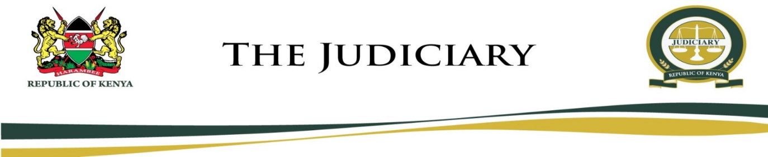
MARIAKANI MAGISTRATE COURT
MAGISTRATE COURT
CALL OVER CAUSE LIST
FRIDAY, 17TH JULY 2020
HON. STEPHEN KALAI NGII - SRM (COURT 1)
MENTION
- MCELC/14/2018 Mwavumbo Group Ranch And George Katsenga Kahindi Vs Said Athman Mlako And Sadiki Mohamed
- MCCC/79/2019 Miheso Fela Ajega Vs Ainushamsi Hauliers Ltd
- MCELRC/22/2020 Luusa Mutinda Vs Aldonai Enterprises Limited
FORMAL PROOF HEARING
- MCCC/489/2017 Elijah Mutuka Thiane Vs Charles Kamencu Mmutua And Excellent Logistics Limited
- MCCC/134/2018 Mbodze Ngoka Vs Abdi Daud Noor
- MCCC/339/2018 Mohamed Shame Chiirma Vs Export Consolidated Services Ltd
PART HEARD HEARING
- MCCC/482/2016 Antony Munyika Vs Steel Makers Limited
FRESH HEARING
- MCELC/168/2017 Jacqueline Kemboi Vs Maurice Nyamongah And Coleman Chengo & 2 Others
HEARING- MAIN SUIT
- MCCC/369/2017 Caleb Amunga Anaminyi Vs Steel Makers Ltd
- MCCC/382/2018 Jumaa Baya Thoya Vs Samuel Ngugi Kimani And Engistruct Africa Ltd
- MCCC/181/2019 Maureen Akinyi Vs Abdul Kadir Mohamed Basalinga And Sons Ltd And Multiple Haulers Ltd
NB: Links to call over will be sent to your respective emails
Hon. S. K. Ngii – SRM
MARIAKANI MAGISTRATE COURT
MAGISTRATE COURT
CAUSE LIST
FRIDAY, 17TH JULY 2020
HON. NELLY CHEPCHIRCHIR ADALO - SRM (COURT 2)

VIRTUAL MENTIONS
- MCCC/463/2017 Moses Mdanya Senerwa Vs Asusa Transporters Limited
- MCCC/335/2018 Pwani Oil Products Ltd Vs African Venture Advertising Ltd And David Ngigi Muturi
- MCCC/356/2019 Omar Yusuf Omar Vs P.n. Mashru
- MCCC/161/2019 Alice Chizi Mwarabu Vs Arstariko Orangi Nyachoti
- MCCC/124/2019 Gladys Jumwa Charo Vs Ronald Juma George
- MCCC /353/2019 Liverson Mwashimba Mwakio Vs P.n.mashru Limited
- MCCC/359/2019 Edwin Chivini Shikuku Vs P.n Mashru Limited
- MCCC/354/2019 Samwel Bongo Marera Vs Badar Hardware Limited
CALL OVER
MATTERS SCHEDULED FOR 21/7/2020
HEARING
- MCCC/63/2013 Omar Mohamed Wazir Vs Sheeji Enterprises K Limited
- MCELC/328/2014 Luvi Mkalla -senior And Japhet Nyanje Mkalla And 4 Others Vs China Road And Bridge Corp And The Area Chief Taru -nyanje Mbovu
- MCCC/587/2016 Jacob Group Mabaiki Vs Signon Group Limited And Simon Baiya
- MCCC/72/2016 Ndegwa Lewa Buru Vs Faustine Ngugi Waweru And Mutua Musyimi

HEARING- APPLICATION
- MCCC/572/2016 Bakari Mohamed Bakari Vs Steel Makers Ltd
- MCCC/502/2016 Salim Robert Saburi Vs Steel Makers
HEARING- MAIN SUIT
- MCCC/576/2016 Anthony Amuleko Amutamwa Vs Steel Makers Limited

NB: Links to call over and virtual mentions will be sent to your respective emails

Hon. N. C. Adalo – SRM

