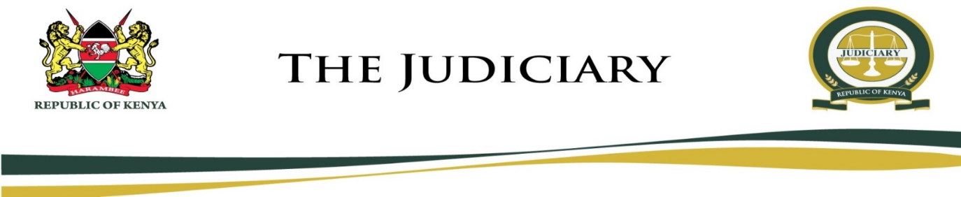
MARIAKANI MAGISTRATE COURT
MAGISTRATE COURT
CAUSE LIST
THURSDAY, 16TH JULY 2020
HON. STEPHEN KALAI NGII - SRM (COURT 1)
09:00 AM
MENTION
- MCCHSO/32/2020 The Republic Vs Idd Karisa Thoya
- MCSO/29/2020 The Republic Vs Julius Nyaki Katana
DEFENSE HEARING
- MCCR/593/2018 The Republic Vs Bernadetty Mkonyo Mthenya
- MCCR/698/2018 The Republic Vs Nathaniel Mwachinga Tsuma
- MCSO/71/2018 The Republic Vs Alex Mwanzia
FRESH HEARING
- MCCR/365/2019 The Republic Vs Juma Mwaipha Karisa
JUDGMENT
- MCCR/575/2019 The Republic Vs Mwauchi Ngaza And John Chisiwa Ngoma

Hon. S. K. Ngii - SRM

MARIAKANI MAGISTRATE COURT
MAGISTRATE COURT
CAUSE LIST
THURSDAY, 16TH JULY 2020
HON. NELLY CHEPCHIRCHIR ADALO - SRM (COURT 2)
09:00 AM
MENTION
- MCCR/682/2019 The Republic Vs Fondo Omar Nzaka
- MCCR/164/2020 The Republic Vs Paul Musembi Chai And James Karisa Kazungu
- MCSO/30/2020 The Republic Vs Ronald Nyanchoka Munga
PART HEARD HEARING
- MCCR/800/2019 The Republic Vs Solomon Wambua Joshua
- MCSO/61/2019 The Republic Vs Edison Baya Thoya

Hon. N. C. Adalo - SRM

