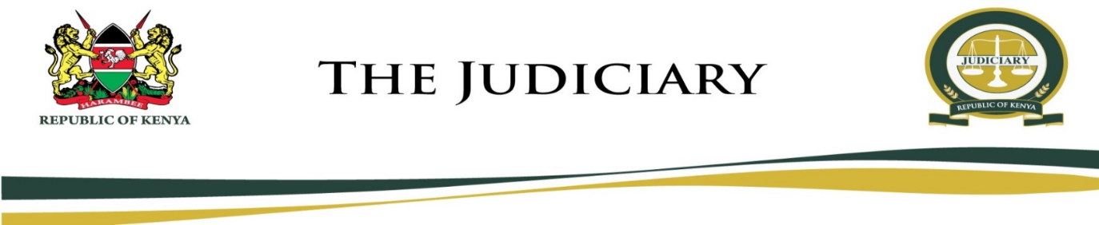
MARIAKANI MAGISTRATE COURT
MAGISTRATE COURT
CAUSE LIST
WEDNESDAY, 15TH JULY 2020
HON. STEPHEN KALAI NGII - SRM (COURT 1)
VIRTUAL (TEAMS)
MENTION
- CC 11/2019 Joyce Samson & Anthr Vs Peter Kanyua & Anthr
(M. S. Shariff Adv) (In Person) at 9:00 am
- CC 151/2015 Mwende Joshua & Anth Vs Neema Parcels Ltd & 2 Othrs
(Muriithi Masore Adv) (Musinga Adv)
(Munyithya Mutugi Adv) (Murimi Ndumia Adv) at 9.30 am
PHYSICAL (IN COURT)
FRESH HEARING
- CC 93/2018 Eugine Wanjala Vs Mombasa M. Millers Ltd
(Anne Kiusya Adv) (V. N. Okata Adv)
- CC 392/2017 Raphael Munuphe Vs China Rd. & B. Corp.
(In Person) (Waithera Ngigi Adv)
- CC 323/2019 Mdune Nyondo Ndune Vs Evans Otwala
(Omondi Waweru Adv) (Hamilton Harison Adv)
- CC 272/2019 Ruwa Mwanza Mwajombo Vs Francis Kamau & Another
(Sherman Nyongesa Adv) (Kairu McCourt Adv)
- CC 270/2018 Elijah Kisyanga Vs Zakhem Int. Const. Ltd
(B. N. Mung’ata Adv) (C. B. Gor & Gor Adv)

Hon. S. K. Ngii – SRM

MARIAKANI MAGISTRATE COURT
MAGISTRATE COURT
CAUSE LIST
WEDNESDAY, 15TH JULY 2020
HON. NELLY CHEPCHIRCHIR ADALO - SRM (COURT 2)
09:00 AM
PLEA
- MCCR/163/2020 The Republic Vs Peter Mwangi Maina
DEFENSE HEARING
- MCCR/711/2017 The Republic Vs Charo Safari Kalume
- MCCR/375/2017 The Republic Vs Shaban Karisa
- MCCR/960/2018 The Republic Vs Paul Thetu Nzomo
FRESH HEARING
- MCTR/1203/2019 The Republic Vs Mohamed Siyab Mohamed
- MCCR/85/2020 The Republic Vs Samson Lusweti

Hon N. C. Adalo – SRM

