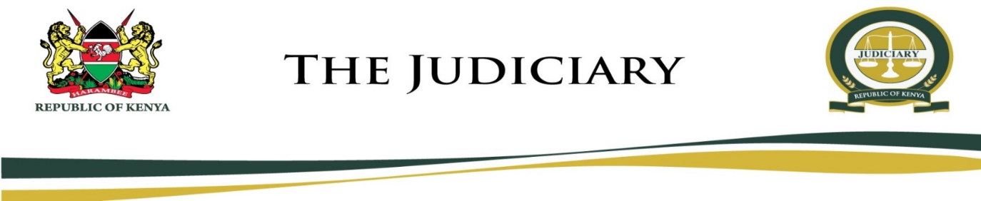
MARIAKANI MAGISTRATE COURT
MAGISTRATE COURT
CAUSE LIST
TUESDAY, 14TH JULY 2020
HON. STEPHEN KALAI NGII - SRM (COURT 1)
09:00 AM
MENTION
- MCCR/814/2018 The Republic Vs Jumaa Tungwa Hamisi
- MCCR/154/2020 The Republic Vs Geoffrey Oduor
DEFENSE HEARING
- MCCR/177/2018 The Republic Vs Stanslus Maina Oyamo
- MCSO/77/2018 The Republic Vs Jackson Mwangi
PART HEARD HEARING
- MCINQ/13/2017 The Republic Vs Ngome Mbetsa Chimaira
FRESH HEARING
- MCCR/71/2016 The Republic Vs Samwel Kilawa Wambua And Kennedy Ngige Kamau And 1 Others
- MCCR/147/2020 The Republic Vs Idd Mohammed Muchiiri

Hon. S. K. Ngii – SRM

MARIAKANI MAGISTRATE COURT
MAGISTRATE COURT
CAUSE LIST
TUESDAY, 14TH JULY 2020
HON. NELLY CHEPCHIRCHIR ADALO - SRM (COURT 2)
MENTION THRO’ EMAIL
- MCCC/543/2016 Boniface Imbundu Vs Tarmal Wire Products Ltd
(Mburu Kariuki Adv) (Mogaka Omwenga Adv)
09:00 AM
PHYSICAL (IN COURT)
FRESH HEARING
- MCCC/423/2015 Willy Tsuma Mwabaya Vs China Road $ Bridge
(Mwaure & Mwaure Adv) (In Person)
PART HEARD HEARING
- MCCC/536/2016 Nyevu Mwalimu Kirao Vs Abdullahi Mohamed And Dzombo Mangale And 2 Others
(Mwaure & Mwaure Adv) (Kairu McCourt Adv)

Hon. N. C. Adalo – SRM

