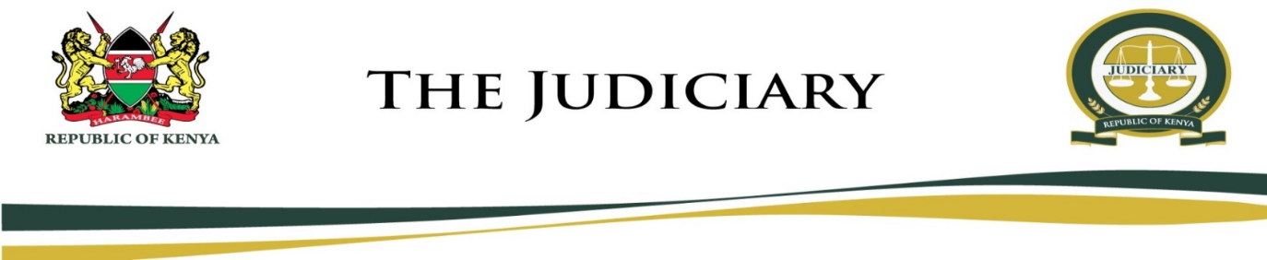
MARIAKANI MAGISTRATE COURT
MAGISTRATE COURT
CAUSE LIST
MONDAY, 13TH JULY 2020
HON. STEPHEN KALAI NGII - SRM (COURT 1)
09:00 AM
KALOLENI G. K. PRISON
VIRTUAL MENTION
- MCCR/883/2019 The Republic Vs Denis Munyao Mutuku
- MCSO/53/2019 The Republic Vs Mwanyae Joto Mbandi
- MCCR/147/2020 The Republic Vs Idd Mohammed Muchiiri
- MCCR/43/2020 The Republic Vs Crisphas Fundi
- MCSO/11/2020 The Republic Vs Juma Chilodi Garero
- MCCR/187/2018 The Republic Vs Kazungu Kitsao Dadu Remus Chidogo Kule Mlewa Charo Jeffa And Salim Katana Karisa
- MCCR/815/2019 The Republic Vs Ali Baya
- MCSO/64/2019 The Republic Vs Emmanuel Chama Katama
- MCCR/800/2019 The Republic Vs Solomon Wambua Joshua
- MCCR/916/2019 The Republic Vs Hamisi Charo Kiwe And Gideon Mkalato Mwambega And 3 Others
- MCSO/69/2019 The Republic Vs Hamisi Tsingua
- MCSO/83/2019 The Republic Vs Joseph Mutinda & 2 Others
- MCSO/77/2019 The Republic Vs Kubuma Tsuma Kasiti
- MCSO/16/2020 The Republic Vs Nathan Kinyua Nyaga
- MCCR/73/2020 The Republic Vs Jofrey Mwachiro
- MCSO/9/2020 The Republic Vs Selfu Beja Chuphi
- MCCR/893/2019 The Republic Vs Shaban Wario Bajila And Abubakar Rashi Haji
- MCCR/573/2019 The Republic Vs Tsuma Chikophe And Tsuma Gereza
- MCSO/44/2017 The Republic Vs Thomas Mutinda Mbuko (rasta)
- MCSO/61/2019 The Republic Vs Edison Baya Thoya
- MCCR/651/2019 The Republic Vs Francis Antony Magero And James Mbugua And 2 Others
- MCCR/796/2019 The Republic Vs Hamisi Mohammed Bakari
- MCCR/85/2020 The Republic Vs Samson Lusweti
- MCCR/761/2019 The Republic Vs Nicholas Ochieng Opicha
- MCCR/805/2019 The Republic Vs Isaac Wabule
- MCCR/465/2019 The Republic Vs Geoffrey Matoke Ontiri
RULING
- MCCR/529/2019 The Republic Vs Hussein Wanjala Wekesa And Stephen Riziki Kaingu
SENTENCING
- MCCR/66/2020 The Republic Vs Mwinyi Chai Ndaa
09:00 AM
SHIMO LA TEWA G. K. PRISON
VIRTUAL MENTION
- MCSO/25/2020 The Republic Vs Peter Mkutano Kubo
- MCCR/918/2018 The Republic Vs Morgan Yawa Kabungu
- MCCR/583/2015 The Republic Vs Sylvester Njagi Ngugi
- MCCR/435/2019 The Republic Vs Nzara Mwachupa Mtende And Mwadalu Zanu
- MCSO/26/2020 The Republic Vs Willy Maundu Katu
- MCCR/113/2019 The Republic Vs Mwayaya Nyamawi Rumba And Rumba Ngedzo Mwayaya
- MCCR/45/2020 The Republic Vs Hamisi Karisa Baya And Kahindi Katana Kombe
- MCCR/568/2019 The Republic Vs Mkala Shanga
COURT (PHYSICAL)
MENTION
- MCCRMISC/11/2020 The Republic Vs Dongoi Mwanzara And Yawa Mwanzara
- MCCR/162/2020 The Republic Vs Mzungu Dzivo Mdoe
- MCCR/157/2020 The Republic Vs Hussein Farid Hassan
- MCCR/158/2020 The Republic Vs Kadide Katana And Mrisa Kadide
- MCTR/246/2020 The Republic Vs Kabale Mwiraghuli
DEFENSE HEARING
- MCCR/668/2018 The Republic Vs Nyae Julo Mbega
- MCCR/592/2018 The Republic Vs Norman Nimrod Kibwana
FRESH HEARING
- MCSO/84/2019 The Republic Vs Bidu Mwandia

Hon. S. K. Ngii – SRM

MARIAKANI MAGISTRATE COURT
MAGISTRATE COURT
CAUSE LIST
MONDAY, 13TH JULY 2020
HON. NELLY C. ADALO - SRM (COURT 2)
9:00 AM
DEFENSE HEARING
- MCCR/535/2019 The Republic Vs Mwachupa Mkala
- MCCR/13/2019 The Republic Vs Nyae Julo Mbega
PART HEARD HEARING
- MCSO/66/2019 The Republic Vs Chidoti Chifui Muungumi
FRESH HEARING
- MCSO/65/2019 The Republic Vs Juma Mwero Mazera
- MCSO/84/2019 The Republic Vs Bidu Mwandia
HEARING
- MCCR/796/2019 The Republic Vs Hamisi Mohammed Bakari

Hon. N. C. Adalo - SRM

